*How to host the website on the cloud platform from scratch*

*By Varun Bansal*

Open your cloud console whether be it AWS, Azure, GCP etc.

* Login to the console and,
* Create a new EC2, VM or Virtual machine.
* Don’t forget to allow inbound traffic rules for

**1) SSH**  port 22

**2)HTTP**  port 80

* And launch the instance and login to the instance.
* I have used RHEL based Linux (RHEL9, fedora or Centos based OS)
* Run the following commands

1. **sudo su –**

to login as a root user.



1. **yum update -y**

to update the packages

1. **yum install httpd -y**

to install the Apache webserver on out instance

1. **service httpd start**

to start the Apache webserver 

1. **chkconfig httpd on**

to check if it the webserver service is on or not.

1. **cd /var/www/html**

go to the directory where all the HTML CSS and JS pages are present

1. **vi index.html**

open the text editor 

1. **press I**

to enter into insertion mode

1. **Enter the following code:** Text

   Description automatically generated with medium confidence

10)**press esc**

to come out of insertion mode.

11)**Press :wq**

to save and exit the vi text editor.

12)**cat index.html**

to see the index.html file.

13) Copy the ip of instance and paste that into web browser

.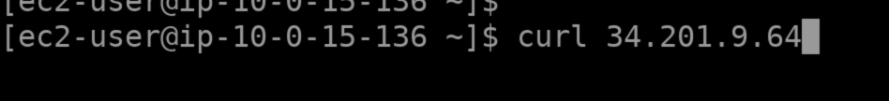

14)**And your website will be hosted.**

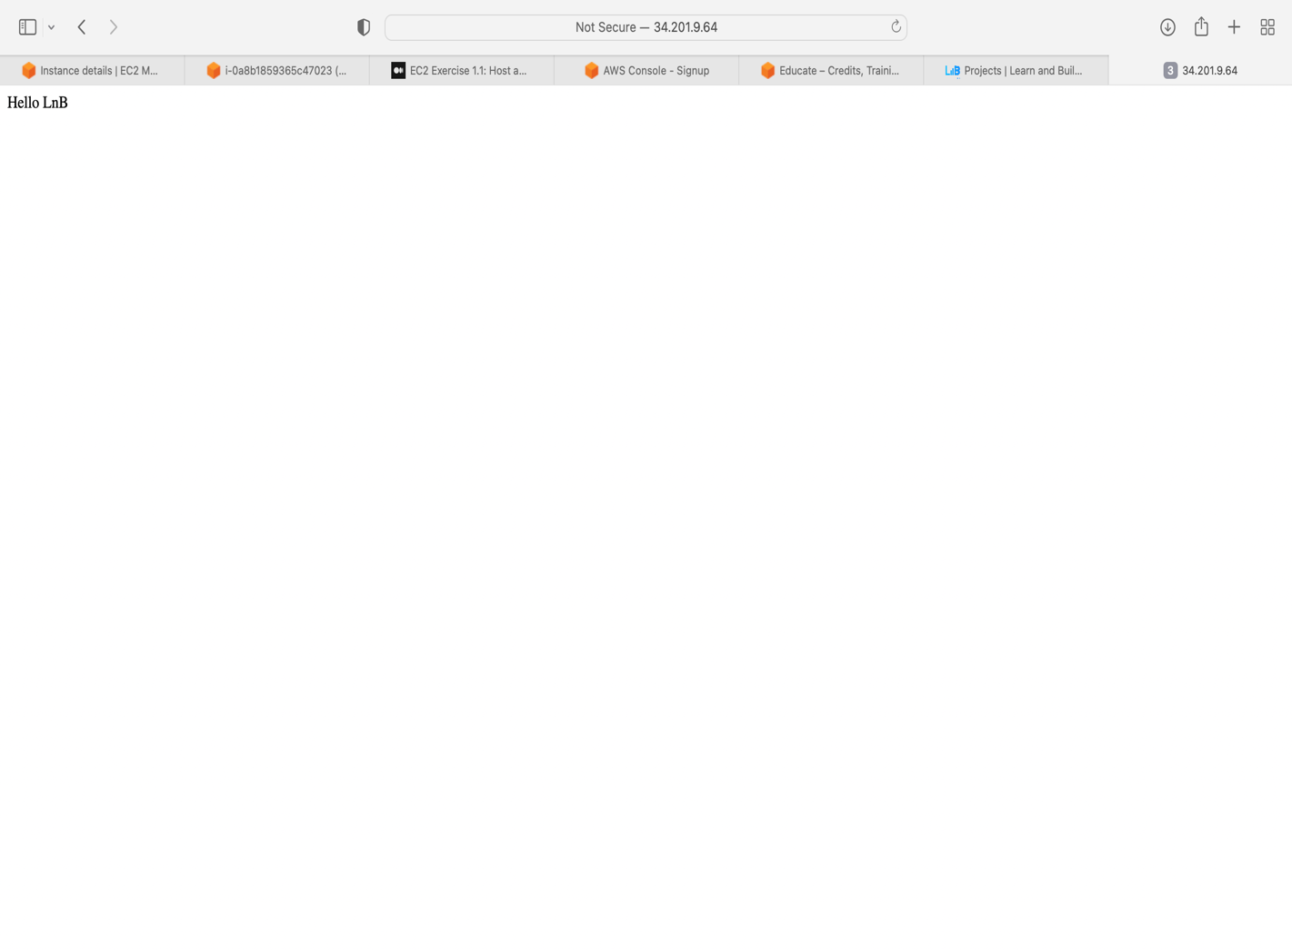

**Thank You !**